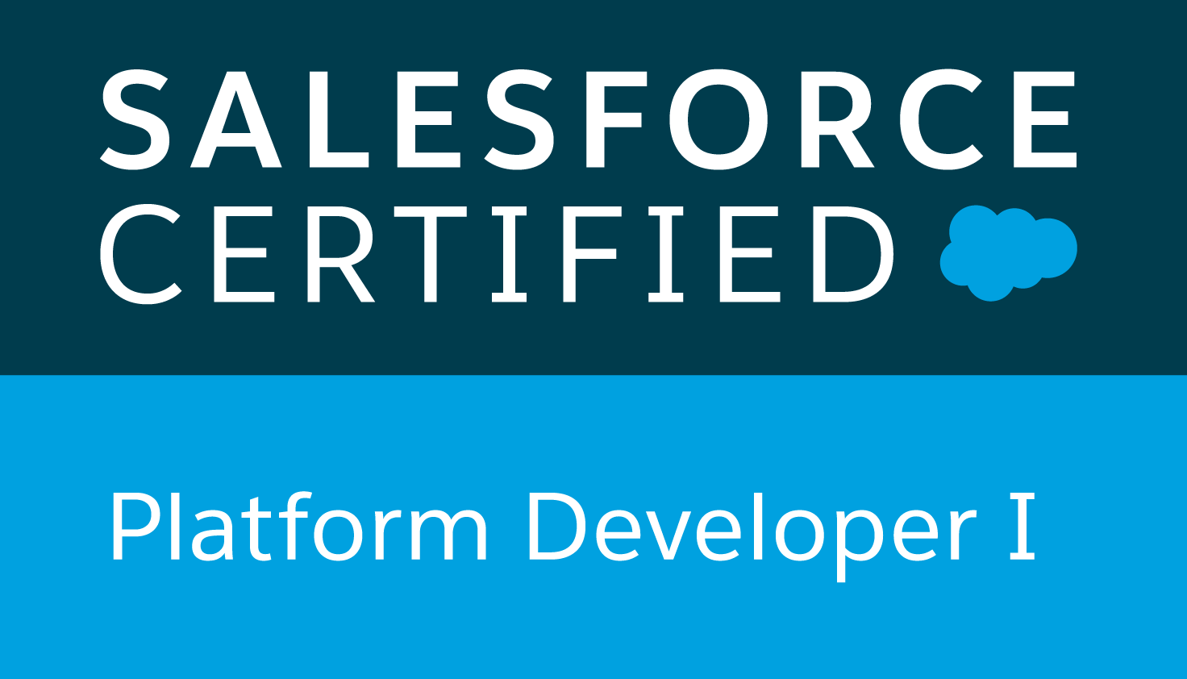
SR. SALESFORCE LIGHTNING DEVELOPER &
ARCHITECT
Mob: +91-7093870658
Email: srinivassalesforcedev1@gmail.com

SREENIVASULU T

SUMMARY

- 9 years of experience in the Salesforce.com CRM Platform both as Administrator and Sr. Developer and Lightning Experience Rollout Specialist.
- Strong experience in implementing Salesforce Sales Cloud, Service Cloud and Lightning.
- Highly experience with Apex development in creating Objects, Triggers, Apex Classes, Standard Controllers, Custom Controllers, Controller Extensions, Lightning Apps and Lightning components.
- Developed Visual force pages and Custom Objects using Apex Programming and Lightning component JavaScript Programming on Salesforce Platform.
- Proficiency in administrative tasks like Creating Roles, Profiles, Users, Email Services, Page Layouts, Workflow Alerts, Actions, Reports and Approval Processes.
- Sound knowledge on Sales force setup menu, Configuration, custom Application Development, Administration, Data Migration and Deployment of applications to Force.com platform.
- Designed various advanced fields like Pick list, Custom Formula Fields, Field Dependencies, Validation Rules, Work Flows, sharing rules and Approval Processes for automated alerts, field updates, and Email generation according to application requirements.
- Implemented security and sharing rules at object, field, and record level for different users at different levels of organization.
- Experience in Lightning Platform Aura framework and Lightning Designing System.
- Experience in Jitterbit, Data loader.
- Strong inter-personal skills with ability to work well in a dynamic team environment.
- Good Experience in using both REST and SOAP APIs.
- Experience in Agile Methodology.
- Experience in full life cycle of software development; requirements analysis, design, development, testing and implementation.
- Having solid knowledge on Amazon Cloud API’s EC2, S3, RDS, IAM, VPC and Route53.
- Having Hands on experience on hosting site on amazon cloud.

TECHNICAL SKILLS
SFDC | Apex Classes, Triggers, SOQL, SOSL, Lightning Frame work, Lightning components, Batch Apex & Schedule Jobs
Integration | Workbench, Web Services, SOAP, IBM Web sphere Cast Iron
Front End & Web | Visual force Pages, HTML, XML, CSS, JAVA Script, Angular
Tools | Force.com IDE (Eclipse), Data Loader, Jitterbit, Apex Explorer.
Design and Development | UML, OOAD, TDD, Eclipse,
Database | SQL and PL/SQL, Postgres

EDUCATION
- B. Tech in Electronics and Communication Engineering from JNTU Hyderabad with an aggregate of 73%.
- Intermediate in MPC from Little angle junior college, Tirupati with an aggregate of 93%.
- SSC from ZP high school, Muchivolu with an aggregate of 83%.

CERTIFICATION
- Certified Salesforce Platform Developer 1.
- Certified solution Architect-Associate by AWS
- Micro services with Spring Cloud -Udemy
WORK
- Working as Senior developer with Etisalat software solutions pvt Ltd from Apr-2014 to Till date
- Previously working as Senior Software Developer in Mobinius Software technologies from Nov 2013 to April 2014.
- Previously working as Consultant-Mobility in SAP Labs, Bangalore from Jun 2013 to Nov 2013.
- Previously working as a Software Developer in Endeavour Software Technologies, Bangalore
From Sept 2012 to Jun 2013.

Lightning PROJECTS

Duration : 8 Months

Role : Salesforce Sr Developer and Technical Architect ( Lightning Apps)

Lightning Project 1: ALTask (Currently working and ready to be published)

https://appexchange.salesforce.com/listingDetail?listingId=a0N3A00000EJGrlUAH

Project Overview:

Assigning and monitoring tasks is at the core of processes to ensure success and time bound deliverables.
AlTask - Native Lighting app which provides a bi-directional email channel for both Salesforce (internal) and Non Salesforce (external) users.
- Admin assigns tasks to users.
- Internal users will see their tasks in their SF login AlTask App Tab.
- External users will receive email with task information and options to update status in a hyperlink.
- User updates the status of the task.
- Admin gets the status updates in his/her AlTask App Tab.
- Admin gets an email from the user intimating the current status of the tasks assigned.

Lightning Project 2: AutoQuote Lightning App (https://appexchange.salesforce.com/listingDetail?listingId=a0N3A00000EJH58UAH)

Project Overview:
AutoQuote a native lightning app that empowers sales team to generate accurate & quick quotes. The app is tightly knitted with Opportunity database.
- User selects product(s) and defines the quantity and apply discount if any.
- A final quote is generated with products and price.
- With a single click send quote to the customer and create an Opportunity, Account & Contact in SF and Customer receives final quote via email.
- App accessible to both internal and external users to generate Quote & receive by E-mail
- Businesses can generate high scored Opportunities
- Enhances customer experience in Quote to Cash scenarios
- Tightly integrated with Accounts, Contacts, and Opportunity objects

Lightning Project 3: Standby (Healthcare)
(https://appexchange.salesforce.com/listingDetail?listingId=a0N3A00000EJGrgUAH)

Project Overview:
This app helps to fill Doctor's open appointment slots with standby patients and notifies patients via email/SMS whenever an appointment slot is available.

- Standby App bridges this gap by seamlessly connecting patients to doctors when a slot opens.
- A patient turned away due to unavailability of appointments can enrol in the standby list.
- When a scheduled appointment gets cancelled with the doctor the patient from the standby list is automatically notified of it via email/SMS. The patient can then confirm the appointment.
- If in case the patient cancels this appointment then the next available patient in the queue is notified.

Responsibilities:
- Created modern Enterprise Lightning Apps combining Lightning Design System, Lightning App Builder and Lightning Component features.
- Upgraded some Apps from Salesforce Classic to Lightning Experience to develop rich user interface and better interaction of pages.
- Worked on Salesforce1 Platform to build Mobile App by enabling Lightning Components for use in Salesforce1 mobile platform to make Lightning Application mobile.
- Created multiple Lightning Components, added CSS and Design Parameters that makes the Lightning
component look and feel better.
- Enabled Aura Framework, by adding Aura Attributes and Aura Handlers for Events to focus on Logic and Interactions in Lightning Applications.
- Minimized code in JavaScript Controllers by adding reusable functions in Helper Component.
- Updated the APEX Controller and Helper functions regularly making the Component Context Aware as per business requirement.
- Tested apps by appending multiple components to a Lightning Application thereby deployed Applications from Sandbox to Production.
- Used refined global search in Lightning by developing Apex classes and Controllers.
- Experienced using Force.com IDE for creating, modifying, testing, and deploying Force.com Applications

Environment: Salesforce.com Platform, Force.com, Force.com Eclipse IDE, Lightning Experience, Lightning
Components, Apex classes and Controllers, HTML, CSS,WSDL, SOQL, SOSL, Scrum, Custom
Objects, Custom fields, Web Services, SOAP, REST.

SFDC Classic PROJECTS

Project: Commission Distribution Program
Duration: June 2015 till Date
Sr. Salesforce Developer

Project Overview:
Commission Distribution Program is a fully customized CRM portal that helps Insurance firm to handle their Leads (Lead Management System) on one hand. Calculate and distribute commissions amongst the brokers/middlemen involved in closing successful opportunities. It is used to calculate the Agent commissions based on the policies created using Production and Statement files. Production file allows the policies with enrolled status and statement file allows the policies with approved status by comparing the existing policies it will create/update the records. By using Jitterbit we automated the process which loads the policy records into Salesforce. Based upon the loads and performance of the Agents the amount is distributed via commission policy through hierarchical process.

Printing checks for Agents and Agencies for amount they earned through commission policy. This is an automated flow where mangers enter check number and takes print of those checks and distribute it to respective Agents and Agencies.

Roles and Responsibilities:
- Created new User Accounts and assigned Profiles as per their role in role hierarchy.
- Defined Org wide default to restrict access from users.
- Customized Page layouts for Standard/Custom objects and assigned Record Types.
- Maintained user Roles, Security, Profiles and workflow rules wherever necessary and successfully implemented Role Hierarchy changes in the organization at the top level.
- Developed various Custom Objects, Tabs, Components and Visual Force Pages.
- Worked with various Salesforce.com objects mostly Account, Contact, Lead, Opportunity, Contract, Case, Site, and Asset.
- Created Email templates in Text, HTML and visual Force necessary for the application.
- Implemented Trigger Framework for Account, Contract and Site Objects with TriggerFactory Class, TriggerFactoryBase Class, Object DispatcherClass, Object HelperClass, ObjectEventHandlerClasses for each and every event defined in Salesforce Triggers to overcome the governing limits.
- Heavily implemented Batch and Schedule classes for auto creation of records for multiple objects and data updations.
- Importing data files from ftp system and uploading the cleansed data into Salesforce using Jitterbit.
- Written several Test Classes following the APEX best practices.
- Created Data Validation rules and Formulas as per business requirement.
- Created Workflow Rules to automate Tasks, Email Alerts, Field Updates, time-dependent actions and Outbound API Messages.
- Created Reports and Dashboards to track Opportunity pipeline/Stages for Management visibility.
- Designed and developed Apex Classes, Controller Classes, extensions and Apex Triggers for various functional needs in the application.
- Defined Impact analysis for all the applications built.
- Designed Web Pages and Controller classes using Visual force and Apex.
- Defined the WorkFlow and Approval process for the Customers’ requests.
- Prepared RCA (Root Cause Analysis) for all the defects.

PREVIOUS ASSIGNMENTS

- TASKIT (Project Management App )
- CEAT TYRES
- PIRAMAL IMPLEMENTATION
- BEST IRS

Tasks Executed:
- Created new User Accounts and assigned Profiles as per their role in role hierarchy.
- Defined Org wide default to restrict access from users.
- Customized Page layouts for Standard/Custom objects and assigned Record Types.
- Created Data Validation rules and Formulas as per business requirement.
- Worked with various Salesforce.com Standard objects like Accounts, Contacts, Leads ,Cases, Campaigns, Reports, and Dashboards.
- Created Workflow Rules to automate Tasks, Email Alerts, Field Updates, time-dependent actions and Outbound API Messages.
- Created Reports and Dashboards to track Opportunity pipeline/Stages for Management visibility.
- Designed and developed Apex Classes, Controller Classes, extensions and Apex Triggers for various functional needs in the application.
- Defined Impact analysis for all the applications built.
- Implemented webservices using both REST and SOAP API.
- Provided the solutions for the service now tickets for the applications running.
- Designed Web Pages and Controller classes using Visual force and Apex.
- Defined the WorkFlow and Approval process for the Customers’ requests.
- Prepared RCA(Root Cause Analysis) for all the defects.
- Prepared the Release notes for all the applications built.
- Worked with the user group for requirement gathering throughout the planning and implementation.
- Implemented the requirements on Force.com platform and Force.com IDE Plug-in using Eclipse.
- Defined Org wide default to restrict access from users.
- Customized Page layouts for Standard/Custom objects and assigned Record Types.
- Designed various Webpages in Visual Force for capturing various customer enquiries and Implemented logic for migrating cases to different queues based on the type of customer enquiry.
- Created and used Email templates in HTML and Visual Force.
- Used SOQL &amp; SOSL with consideration to Governor Limits for data manipulation needs of the application using platform database objects.
- Responsible for all the activities related to configuring Data Loader, uploading data in CSV files into Salesforce.com, checking for the correctness of the data.

