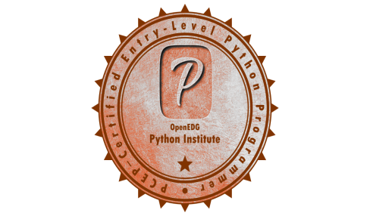

Gayatri Bhuyan

Email: gayatri1988@yahoo.com

Mobile: +91 7411364231

Deloitte Consulting

Python Certified Programmer- PCEP

Summary of Experience and Qualifications

* Around 3 years of IT experience in Deloitte USI working as AWS/Azure Cloud Data Engineer in Health Care and Pharmaceutical industries
* Expertise in AWS Cloud Serverless Analytics including AWS ETL Glue, AWS Athena, AWS Lambda, RDS Aurora, DMS and AWS CloudFormation template
* Expertise in Python, Pyspark, SQL and AirFlow orchestration tool
* Working Knowledge in Azure Data Factory, Databricks & ADLS
* I am having expertise in Sqoop, Hive, Oozie, HDFS & Python Scripting
* I have extensively worked on Data Extract, Transform and Load from various data sources to Data Lake
* Implemented batch data transformation by using Spark with Python script
* Proficient in providing efficient solutions for Data Discovery, Enterprise BI, Ad-hoc reporting
* Generated Tableau Dashboard with quick/context/global filters, parameters, and calculated fields on Tableau 10.x
* Good Knowledge of Microsoft Office Suite including MS Excel, advanced Excel

**Experience:** Deloitte Consulting, Bangalore

**Project: 1**

**Industry:** HealthCare

**Project:** GeoSAD

**Client:** Healthcare & Pharma Industry

**Role:** Data Engineer

* Store data in the Data Lake built on AWS S3 storage and generate the schema by using AWS Glue and interact S3 data using AWS Athena
* Use PySpark to transform data in the different layers of Data Lake
* I worked in development like AWS Database Migration Services to migrate the data from different client systems to Aurora
* I have also worked on building of Data Pipelines from different client source systems to AWS Data Lake by using AWS Glue, Lambda, Python, PySpark and build automation framework by using AirFlow

**Technical Environment**: AWS Lambda, Aurora, DMS, AWS S3, AWS Glue, PySpark, AWS CloudFormation template, AirFlow and Python

**Project: 2**

**Industry:** HealthCare

**Project:** Covid-19

**Client:** Healthcare & Pharma Industry

**Role:** Data Engineer

* Extracting data from different covid-19 data sources to AWS Data Lake Storage
* Worked on different transformation logics by using PySpark tech stack

**Technical Environment**: AWS Glue, Aurora, PySpark, Airflow and Python

**Project: 3**

**Industry:** HealthCare

**Project:** Legal Exchange and Physician Research, WPS

**Client:** Healthcare & Pharma Industry

**Role:** Data Engineer

* I have worked as a tester by testing different modules of ETL and data transformation logics
* Uploading the test scripts into JIRA and executing them
* I usually present the demo on JIRA and different test scripts to different stack holders on different functionality

**Technical Environment**: AWS Stacks( Glue, S3, AWS CloudFormation template) , AirFlow and JIRA

**Work Experience:** Deloitte Consulting, Bangalore since March-2020 to till date

**Qualification**: BTech from VTU, Bangalore

**Certification**: PCEP- Python Certified Programmer