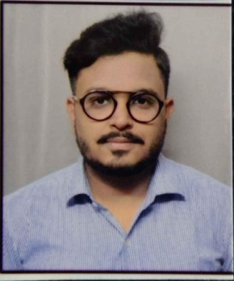**APOORV SHARMA**



**About Me**



7093588318



Experience 1.7 years



Linkedin.com/in/apoorv2201



johneyapoorv@gmail.com

**Objective:**

Targeting a Software Engineer position in an organization where I can contribute to organization goals and enrich my skills according to the latest technologies.



**Education**

|  |  |  |  |
| --- | --- | --- | --- |
| **QUALIFICATION** | **UNIVERSITY/BOARD** | **AGGREGATE** | **YEAR OF PASSING** |
| 10TH (ICSE) | CITY MONTESSORI SCHOOL | 79.86% | 2013 |
| INTERMEDIATE (ISC) | LUCKNOW PUBLIC SCHOOL | 72.75% | 2015 |
| B.TECH(CSE) | GURU NANAK INSTITUTE OF TECHNICAL CAMPUS  ( JNTUH affiliated ) | 61.12% | 2019 |



**Skills**

* AMAZON WEB SERVICES
* PYTHON
* MACHINE LEARNING
* DATA ENGINEERNG
* TABLEAU
* Core java(logical programming skills)
* Core C(logical programming skills)

**PROJECTS**

* Completed a database management system for a website which provides information about pre and post-graduation colleges in India
* Implementing machine learning concepts in AWS using AMAZON SAGEMAKER, S3 BUCKET, EBS, EC2 services.
* Design and development of a CLOUD based Online Election System using OPENSTACK.
* Implementation of MACHINE LEARNING algorithms and DATA PROCESSING on the HDFC bank databases.

**EXPERIENCE**

**POSIDEX TECHNOLOGIES** (04/09/2019 - 05/04/2021)

* Associate Software Engineer in data science domain handling machine learning algorithms on banking data in the middle ware layer of the development, Name tokenization based on machine learning tool ,Natural language processing, data manipulation, data wrangling , data modeling, web scraping, data visualization, data verification, worked on Linear regression, KNN ,Naïve baye's, Svm, Logistic regression, Decision trees. Hands on FLASK APIs



**Personal Traits**

* Ability to lead, team work and collaboration skills to work with others to achieve project objectives
* Excellent presentation and written communication skills
* Self motivated, skill of convincing people
* Positive thinking and smart working approach
* Good grasping quality ability to imbibe things
* Flexible to work under pressure and strives to exceed expectations



**Achievements**

* Certified by REDHAT on cloud computing concepts
* Certified online course in JAVA
* Certified online course in PYTHON
* Deputy CEO of E-CELL at college
* Team leader for college project



**Personal Details**

NAME:APOORV SHARMA

FATHER’S NAME: HIRDESH SHARMA

D.O.B.-22ND JANUARY 1998

MARITIAL STATUS: SINGLE

LANGUAGES KNOWN: HINDI, ENGLISH

HOBBIES: Singing, playing guitar, writing poetry, writing and composing songs.

**DECLARATION:**

I hereby declare that all the above information is true and correct the best of my knowledge an belief.

DATE:

SIGNATURE

(APOORV SHARMA)